

**AQARY App Project**

**2024/2025**

**Created By:-**

**Mohamed Salah Abdulla**

**Mohamed Fathi khalifa**

**Mahmoud khalid Mustafa**

**AQARY**

**The goal of this project is to provide a mobile application for the clients and a web-portal for Property Owners and Company’s administrators. The “AQARY””عقاري” is a mobile application, which helps people to find the needed apartment or house or land based on their interest. Users view the ads which have uploaded by brokers. The Brokers can provide their property information using the web-portal. An administrator of the web-portal verifies ads and manages user information. The mobile application requires Internet connection to fetch real-time results. All system information is maintained in a database, which is located on a web-server.**

**The mobile application integrate with the GPS-map API ( not a navigator) to be able to show the exact location of the property.**

**A first-time user of the mobile application should see the log-in page when he opens the application. If the user has not registered, he should be able to do that on the log-in page. If the user is not a first-time user, he should be able to see the search page directly when the application is opened. The user chooses the type of search he wants to conduct. Every user should have a profile page where they can edit their e-mail address, phone number and password. Also, the user can set the mobile application to his preferred language.**

**Involved Parties**:--  
**1: AQARY Admins**

**2: Brokers**

**3: final customer**

**4: Application Development Company**

# **Requirements SPECIFICATION :-**

* **Brand New Mobile Application for customers who seek to buy a property from trusted companies.**
* **A web portal for admins and companies to manage the data on the application.**
* **The app will provide the customers with a lot of categorized information about the unit like the size , floor number, in-house photos , establishment date , Apartment finishing degree , general address ( but not exactly address).**
* **Integration with maps to show only the city location.**
* **Once the customer click interest on any a unit, the unit owner will get notification including the customer communication data.**
* **Once the customer click Book on any a unit, the unit owner will get notification including the customer communication data and the customer will be directed to pay an advance payment.**
* **The mobile application will need a network connection to fetch a real time data.**
* **All system information is maintained in a database, which is located on a web-server.**

# **rule requires:-**

**1: Manager**

* **Management:-**
* Oversee the company's overall operations, and develop strategies for business growth and success.
* **System Control :-**
* Manage the website or app by controlling user permissions and accounts. Add, delete, or modify system users and data as needed.
* **Monitoring:-**
* Track the performance of all departments, ensuring targets are met. Review financial reports and set budgets.

**2: Marketers**

* **Management:-**
* Create and upload advertisements for property units. Ensure that listings are accurate, engaging, and updated.
* **Communication:-**
* Schedule property viewings with clients. Communicate effectively with potential buyers or tenants to close deals.
* **Sales Process:-**
* Manage the sales or rental process from inquiry to final agreement. Achieve set sales/rental targets as assigned by the management.

**3: Admin**

* **Management:-**
* Maintain accurate and organized records of properties, clients, and sales. Handle system updates, such as property listings and user account details.
* **Communication and Support:-**
* Assist marketers and managers by preparing reports or documents. Address technical issues related to the platform

**4: Client**

* **Management:-**
* Create and maintain a personal account to track all relevant details. Provide accurate personal data for profile verification.
* **Communication:-**
* Create and maintain a personal account to track all relevant details. Provide accurate personal data for profile verification.
* **Review:-**
* Share reviews or feedback regarding services or properties.

# **Use-Cases Diagram:-**

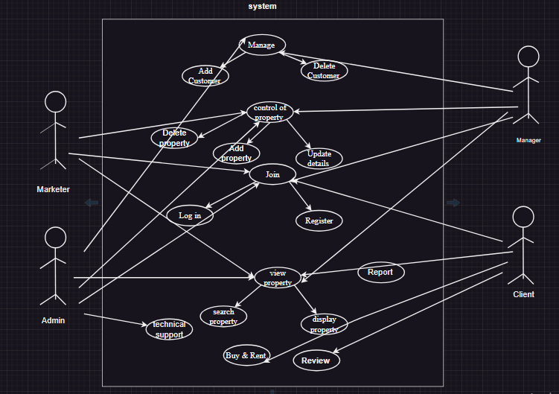

**Sources used:-**

1. [**https://www.geeksforgeeks.org/use-case-diagram/**](https://www.geeksforgeeks.org/use-case-diagram/)
2. **<https://sparxsystems.com/resources/tutorials/uml/use-case-model.html>**

|  |  |  |  |  |
| --- | --- | --- | --- | --- |
| **Task** | **Mission:** | **Mohamed Salah** | **Mohamed Fathi** | **Mahmoud Khaled** |
| **Task**  **01** | **The App Idea** |  | **√** | **√** |
| **Write the idea on word** | **√** |  |  |
| **Print the paper** |  |  | **√** |
| **Task**  **02** | **Prepare the requirement specification** | **√** |  |  |
| **Write the requirement on word** | **√** |  |  |
| **Print the paper** |  |  | **√** |
| **Task**  **03** | **Prepare the rule requires** |  |  | **√** |
| **Write on word and**  **Use Case Diagram** |  | **√** |  |
| **Use of information source** |  | **√** |  |
| **Print the paper** | **√** |  |  |
|  |  |  |  |  |
|  |  |  |  |  |
|  |  |  |  |  |
|  |  |  |  |  |
|  |  |  |  |  |
|  |  |  |  |  |
|  |  |  |  |  |
|  |  |  |  |  |
|  |  |  |  |  |

**Who Did What (Follow Up table)**